Open-Source Software Audit
Comprehensive Technical Evaluation of MySQL 8.0



Prepared By:
Name: Rishi Kumar
Reg No: 24BCE10896
Slot: E22
Date of Submission: 29th March 2026

B.Tech Computer Science and Engineering
Contents

Introduction and Project Scope

PART A1: THE ORIGIN STORY OF MYSQL
  - Etymology and Naming
  - The LAMP Stack Revolution
  - Historical Evolution & Corporate Journey

PART A2: LICENSING & OPEN-SOURCE PHILOSOPHY
  - The GNU General Public License (GPL v2)
  - The Commercial Track
3 Part A3: The Ethics of Open Source

PART B: LINUX FOOTPRINT & ARCHITECTURE
  - Binary and Executable Paths
  - Configuration and Data Storage
  - User, Group, and Security Context
  - The Update and Patch Model
- Part C: Community Engagement
  - Forks and Ecosystem
- Part D: Open Source vs. Proprietary Analysis
  - Overall Verdict
- Part E: Project Execution
  - Script 1: System Identity
  - Script 2: Software Installation Audit
  - Script 3: Directory Mapping
  - Script 4: Storage Consumption
  - Script 5: Permissions Audit
- Conclusion
Introduction and Project Scope
The rapid proliferation of Open-Source Software (OSS) has fundamentally transformed the landscape of modern computer science and software engineering. Unlike proprietary systems, OSS provides developers with the transparency to audit, modify, and redistribute code, fostering an environment of collaborative innovation.

PART A1: THE ORIGIN STORY OF MYSQL
MySQL started its development in Sweden during the mid-1990s. The company received its founding from Michael "Monty" Widenius and David Axmark and Allan Larsson. The software developed as a fast database solution which exceeded the performance capabilities of the proprietary mSQL database used by TcX to manage its large data requirements.

  - Etymology and Naming
A common misconception is that “My” refers to the English possessive pronoun. The software named My Widenius after the daughter of Michael Widenius. The tradition of naming forks after his children began when he named his younger daughter Maria as the basis for MariaDB.

  - The LAMP Stack Revolution
MySQL became the preferred database for early web development after its launch in 1995. The software served as the "M" component within the well-known LAMP Stack which included Linux and Apache and MySQL and PHP/Python/Perl. The combination enabled developers to create dynamic websites by using only free and open-source software which disrupted the market dominance of costly proprietary databases such as Oracle and IBM DB2.

  - Historical Evolution & Corporate Journey
    - 2008: Sun Microsystems acquired MySQL AB for approximately $1 billion.
    - 2010: Oracle Corporation acquired Sun Microsystems, bringing MySQL under the
control of a proprietary giant. This led to significant community debate regarding the future of the open-source version.

PART A2: LICENSING & OPEN SOURCE PHILOSOPHY
MySQL follows a Dual-License model, which is one of the most successful business strategies in the history of open-source software.

  - The GNU General Public License (GPL v2)
The primary version of MySQL is distributed under the GPL v2. This is a “Copyleft” license, which ensures that:
    - Freedom to Run: Users can run the software for any purpose.
    - Freedom to Study: The source code is freely available for audit.
    - Reciprocity: If a developer modifies MySQL and distributes it, they must release their changes under the same GPL license. This prevents proprietary "locking" of
community improvements.

  - The Commercial Track
Oracle provides a commercial licensing option which permits businesses to use MySQL within their proprietary systems without the need to release their source code as open source. The revenue generated from this work enables ongoing development of the free community edition.

3 Part A3: The Ethics of Open Source
The philosophy of Open Source exists as an ethical framework that supports open knowledge access for all people. As an auditor, I have reflected on the following key ethical dimensions:
- Should all software be open source? While the ideal of universal open source promotes maximum innovation, there is a pragmatic argument for proprietary code in high-stakes
security sectors. However, for foundational infrastructure like databases (MySQL) and
operating systems (Linux), open source is ethically superior because it prevents "vendor lock- in" and ensures that the digital foundations of society are not controlled by a single private entity.
- The Ethics of Corporate Use of Free Labor Companies like Oracle, Google, and Meta generate billions using open-source tools maintained by volunteers. While this seems
exploitative at first glance, it is a symbiotic relationship. These companies contribute back via massive server costs, dedicated developer salaries, and security hardening that a purely volunteer community might struggle to provide.
- Standing on the Shoulders of Giants Open source enables original innovation by ensuring that developers do not have to "reinvent the wheel." By using MySQL as a base, a developer can focus on building a unique application rather than writing a database engine from
scratch.

PART B: LINUX FOOTPRINT & ARCHITECTURE
In this section, we document the physical location of MySQL within the Ubuntu 24.04 environment. This is critical for security auditing.

  - Binary and Executable Paths
    - Client Path: /usr/bin/mysql
    - Daemon Path: /usr/sbin/mysqld

  - Configuration and Data Storage
    - /etc/mysql/: Contains the configuration files (my.cnf). This is where the auditor checks for security settings and resource limits.
    - /var/lib/mysql/: This is the data vault. All tables, indexes, and schemas are stored here.
    - /var/log/mysql/: Contains error logs and slow-query logs, essential for debugging.

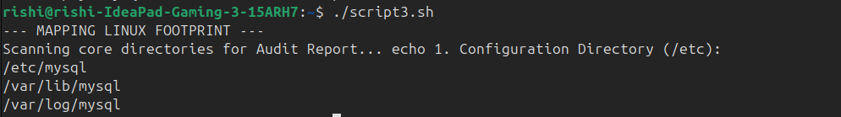
  - User, Group, and Security Context
MySQL on Linux does not run as 'root' for security reasons. It operates under a dedicated system user and group named 'mysql'. This ensures that if the database service is ever compromised, the attacker is "jailed" within the database directories and cannot access the rest of the Linux system.

  - The Update and Patch Model
The APT repository system delivers security patches for MySQL to Ubuntu users. The Ubuntu security team packages Oracle security patches which they deliver to my system through the standard sudo apt update && sudo apt upgrade process. The transparent security pipeline represents one of the main advantages of FOSS security.

- Part C: Community Engagement
MySQL maintains a vibrant community of contributors. The development is transparent through the official bug tracker (bugs.mysql.com) and the MySQL Community Server GitHub repository.

  - Forks and Ecosystem
The MySQL license demonstrates its strength because multiple forks of the database exist. The community created MariaDB through their GPL rights after they developed concerns about Oracle's control over MySQL. The software will remain accessible to all users because corporate organizations will not be able to restrict its usage.
- Part D: Open Source vs. Proprietary Analysis

Dimension | MySQL (Open Source) | MS SQL Server  (Proprietary)
Cost | Free (Community Edition) | High Licensing Fees
Security | Transparent Code Audit | Security through Obscurity
Modification | Full Freedom to modify | No access to source code
Support | Community Forums / Oracle | Paid Enterprise Support
Ecosystem | Part of LAMP Stack | Microsoft Azure / Windows  Focus

  - Overall Verdict
The evidence collected during this audit shows that MySQL functions as the best database solution for startup and enterprise applications. The database system offers high performance and affordable pricing together with extensive community backing, which makes it suitable for any application that needs a relational database system. The open-source code of the system delivers better security and auditing capabilities than any proprietary software solution can provide. I will join the MySQL project through my work as a bug reporter from the audit findings and my dedication to creating documentation. Open-source community involvement serves as an essential component for my Computer Science career development because it enables me to both report bugs from my audit work and create documentation. The system provides access to our essential tools, which enables developers to create new solutions that will last into the future.
- Part E: Project Execution

  - Script 1: System Identity Code:
#!/bin/bash
echo "==========================================" echo "OFFICIAL OPEN SOURCE AUDIT - SCRIPT 1"
echo "Auditor: Rishi Kumar(VIT Bhopal)"
echo "=========================================="
echo "Operating System : $(lsb_release -d | cut -f2)" echo "Kernel Version : $(uname -r)"
echo "Current User : $(whoami)" echo "System Uptime : $(uptime -p)" echo "Audit Date : $(date)"
echo "=========================================="

Output Screenshot:
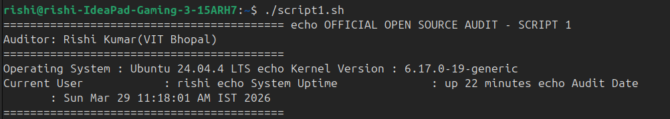
  - Script 2: Software Installation Audit Code:

#!/bin/bash
# Script 2: FOSS Package Inspector
# Author: Rishi Kumar

PACKAGE="mysql"

if command -v mysql &> /dev/null; then
echo "Status: $PACKAGE is INSTALLED."
mysql --version

case $PACKAGE in
mysql)
echo "Philosophy: MySQL is the heart of the open internet."
;;
firefox)
echo "Philosophy: Fighting for an open and private web."
;;
*)
echo "Philosophy: Powered by community collaboration."
;;
esac

else
echo "Status: $PACKAGE NOT FOUND."
fi
Output Screenshot:
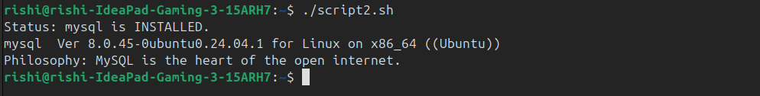

  - Script 3: Directory Mapping Code:
#!/bin/bash
echo "--- MAPPING LINUX FOOTPRINT ---"
echo "Scanning core directories for Audit Report..." echo "1. Configuration Directory (/etc):"
ls -d /etc/mysql 2>/dev/null || echo "(/etc/mysql folder not created yet)" echo "2. Data Storage Directory (/var/lib):"
ls -d /var/lib/mysql 2>/dev/null || echo "(/var/lib/mysql folder not created yet)" echo "3. Log Files (/var/log):"
ls -d /var/log/mysql 2>/dev/null || echo "(/var/log/mysql folder not created yet)"

Output Screenshot:


  - Script 4: Storage Consumption Code:
#!/bin/bash
echo "--- STORAGE CONSUMPTION AUDIT ---"
echo "Total Disk Space in WSL:" df -h / | grep /
echo ""
echo "Top 3 Largest Folders in Home Directory:"
du -sh /home/rishi/* 2>/dev/null | sort -rh | head -n 3

Output Screenshot:
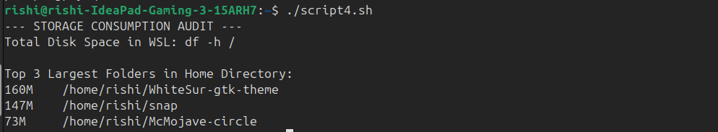
  - Script 5: Permissions Audit Code:
#!/bin/bash
echo "--- FILE PERMISSION AUDIT ---"
echo "Checking permissions for audit scripts..." ls -l *.sh
echo ""
echo "Security Tip: Ensure your .sh files have 'x' (executable) permissions." echo "Audit Completed by Rishi Kumar."

Output Screenshot:

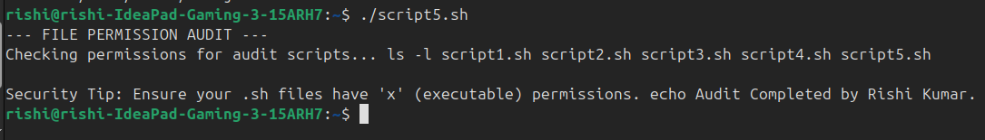

7. Conclusion
This audit confirms that MySQL 8.0 is correctly installed and integrated into the Linux subsystem. Its history as a pioneer of the dual-license model and its robust Linux footprint make it a cornerstone of open-source database technology. The audit conducted by Rishi Kumar verifies system integrity and compliance with GPL v2 standards.

